LAB : 1
PART – A :

PWD : present working directory.

LS : give the list of the directories.

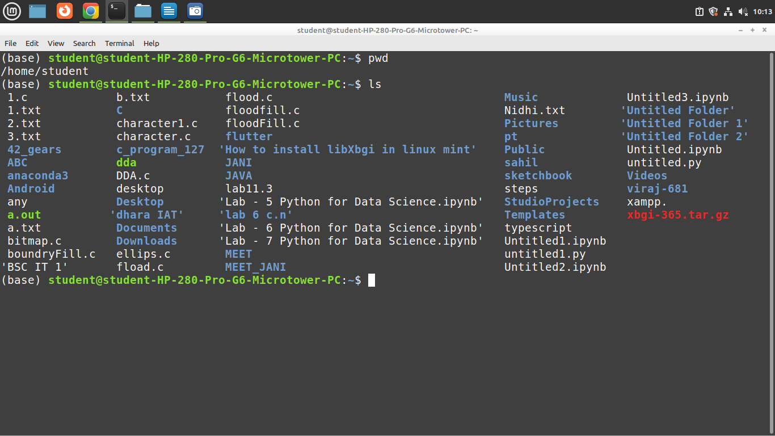

clear : to clear the terminal.

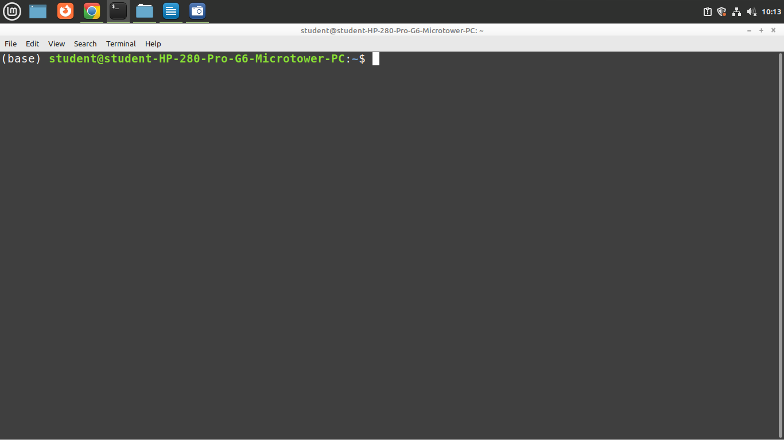
Mkdir folder_name : to make the directory

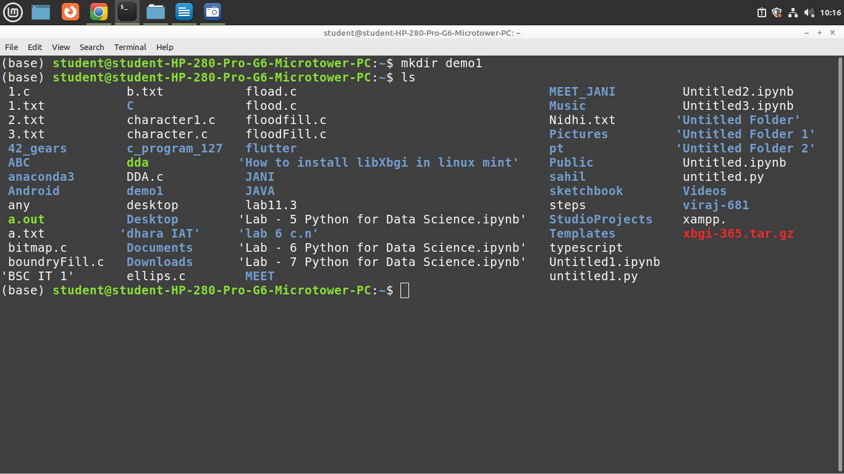
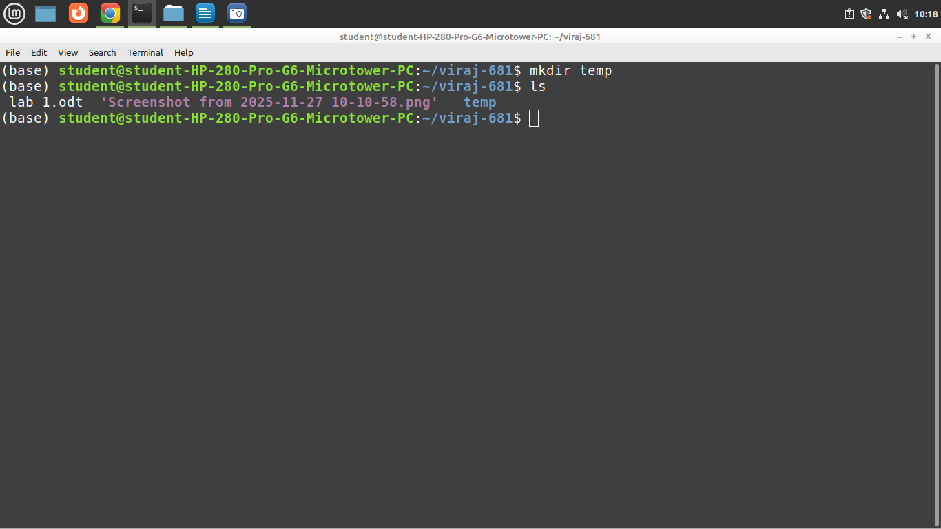

to get the help for any command use :

command_name –help

cal : to get the calender of the current month
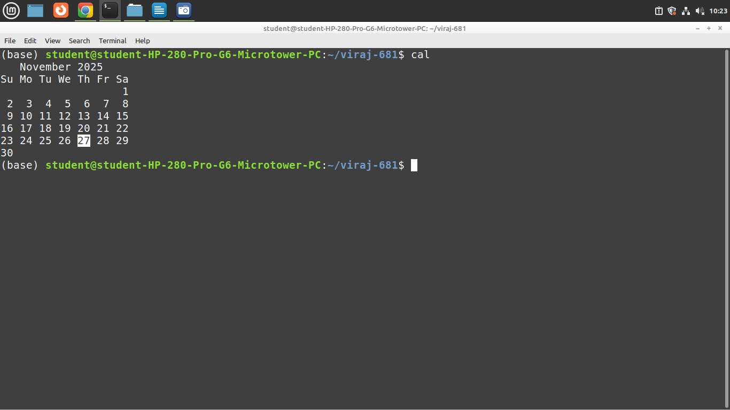
date : to get the today’s date
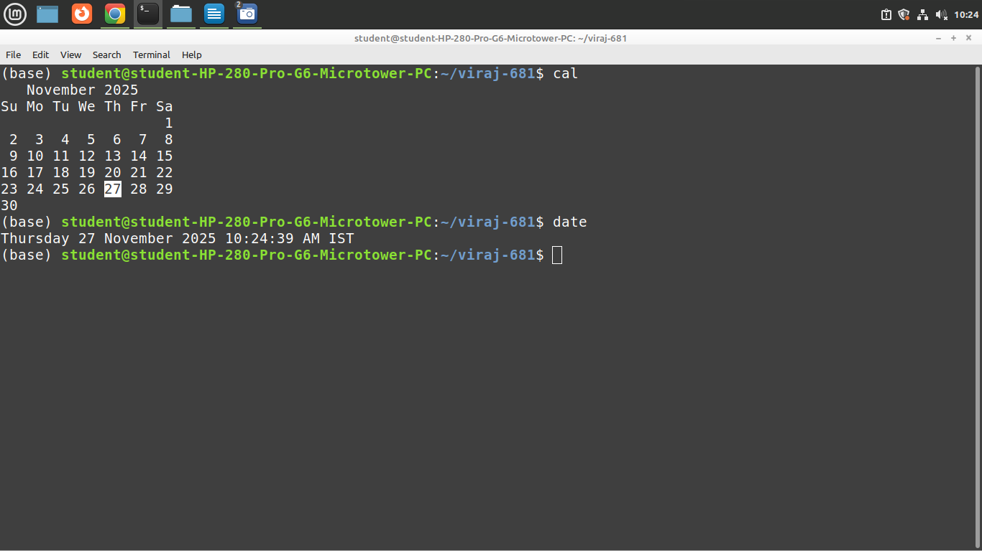
cat :
> is used for the redirection if file no found make a new one.and you can give the content of it. Old content is overwrite by new content.

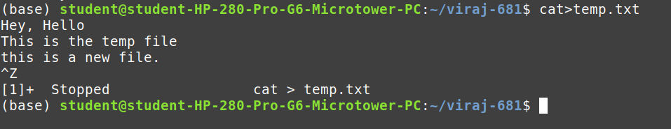
Echo :

to print in terminal

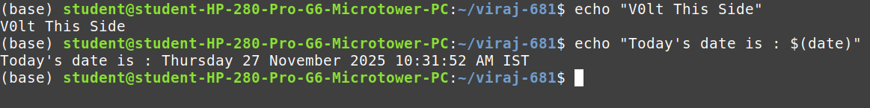
>> : create new file(redirection) and append the data given by the command
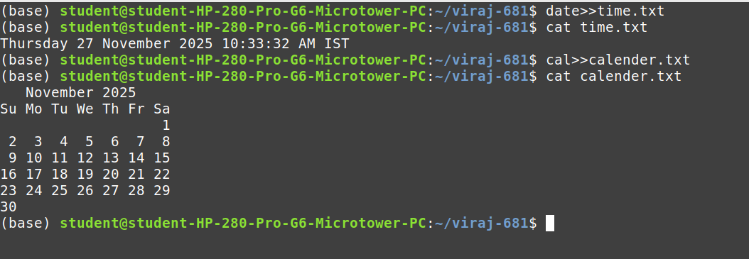
formatin date commands :
PART – B :
question – 2 :

normal commands to know :
cd / : to goto root
cd .. : to go one level up
cd path : to go to the specific path

question – 1:

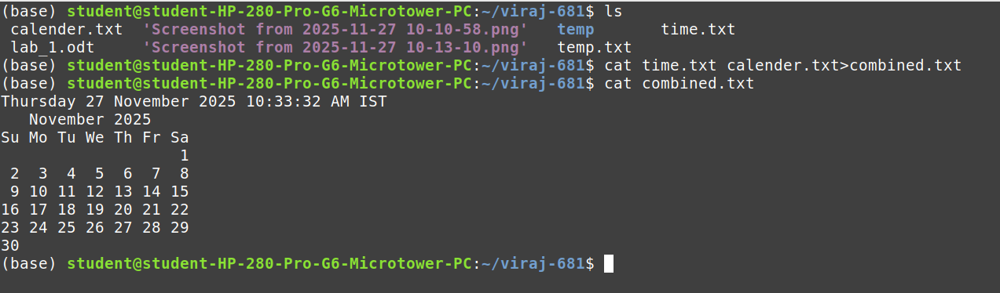

question – 3

